Database System Engineering and Distributed Backend Development
Course Code: 25CS13002E
ROLL NO:2520030531
NAME: D. Venya sri

SQL PRACTICE NOTES - PHYSICIAN & DEPARTMENT TABLES

Query 1: Create Data Base
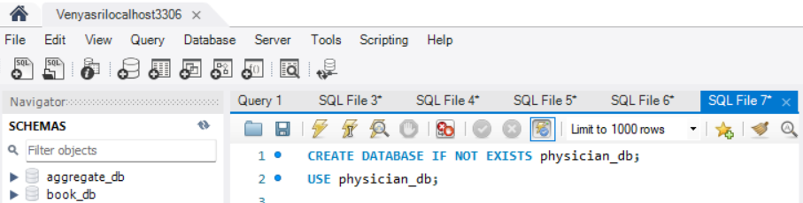
Output:
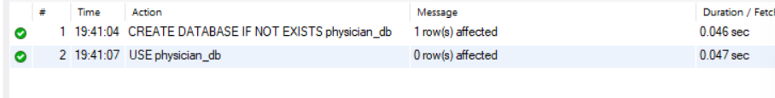
Query 2: CREATE PHYSICIAN TABLE
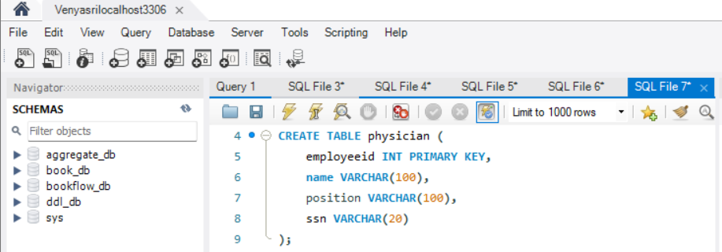
Output:

Query 3: INSERT DATA INTO PHYSICIAN
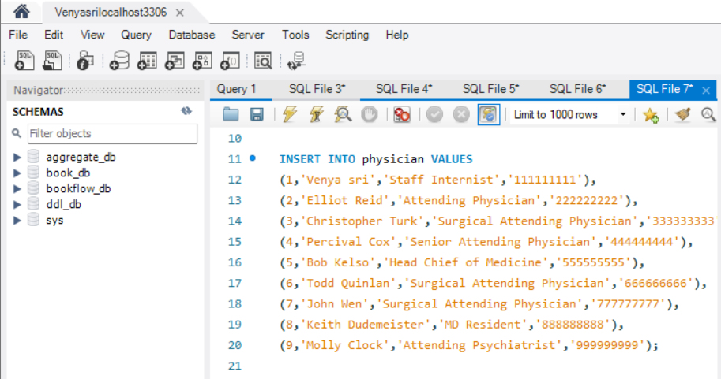
Output:

Query 4: CREATE DEPARTMENT TABLE
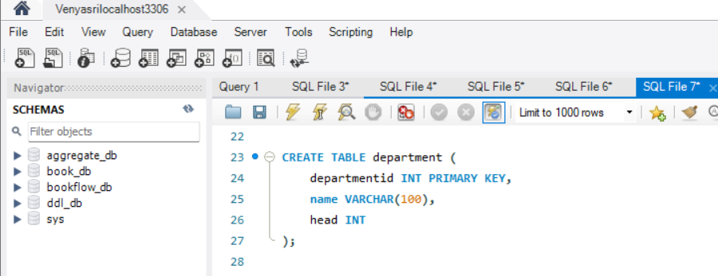
Output:

Query 5: INSERT DATA INTO DEPARTMENT
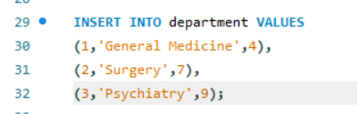
Output:
Query 6: INNER JOIN
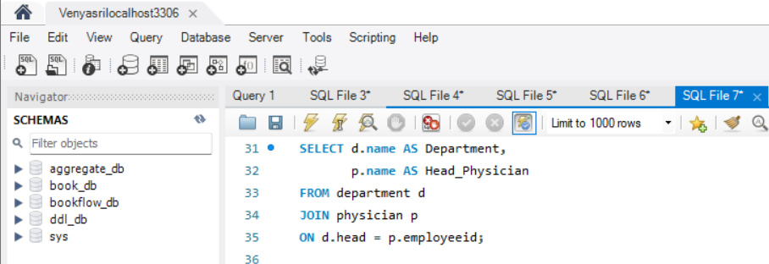
Output:
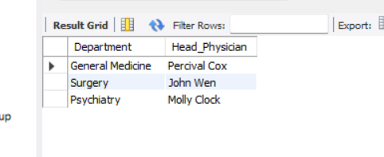

Query 7: WHERE CLAUSE
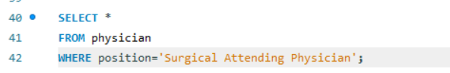
Output:
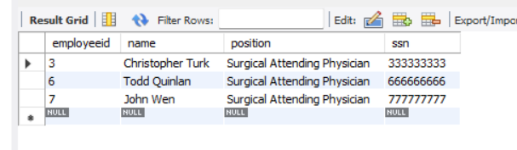

Query 8: WHERE + LIKE
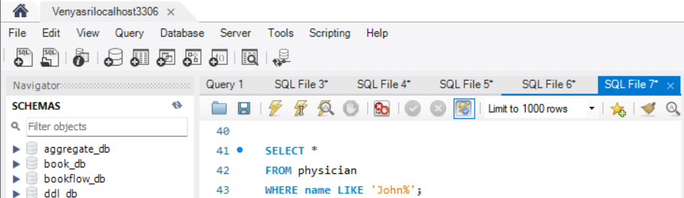
Output:
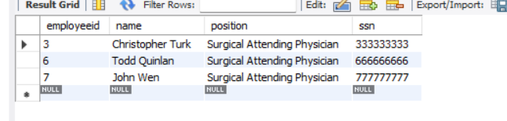

Query 9: COUNT()
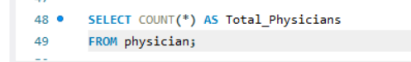
Output:
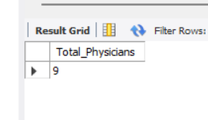

Query 10: COUNT DISTINCT
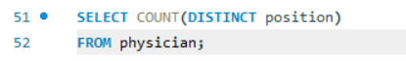

Output:
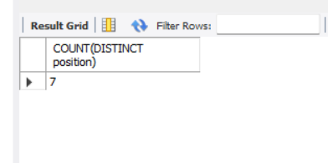

Query 11: GROUP BY
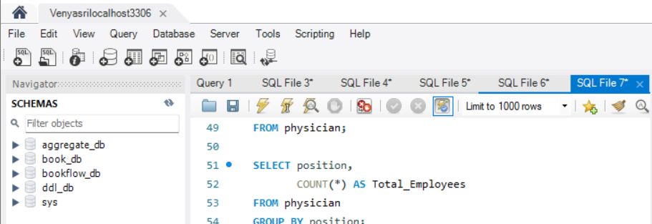
Output:
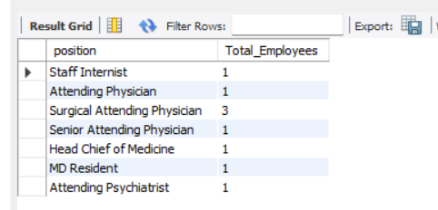

Query 12: GROUP BY + HAVING
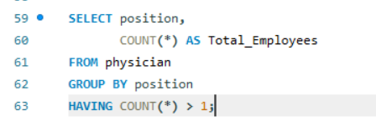
Output:
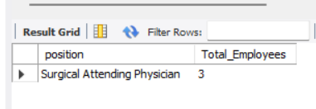

Query 13: ORDER BY
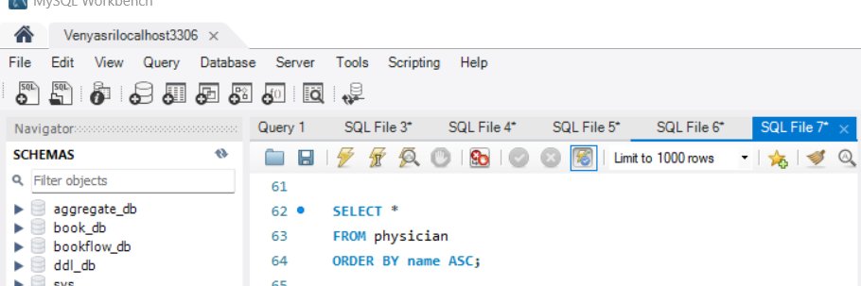
Output:
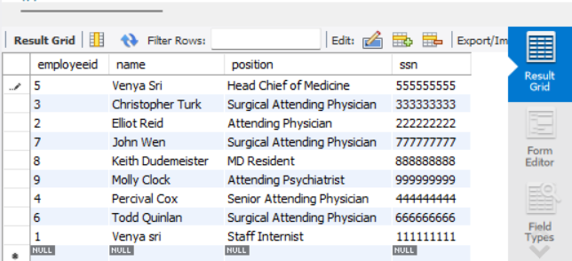

Query 14: ORDER BY DESC
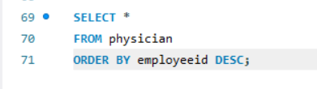

Output:
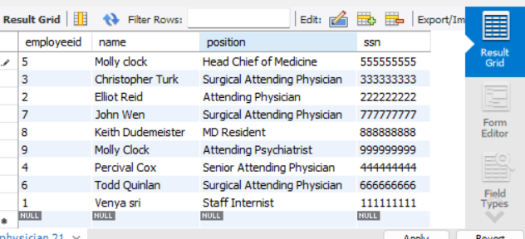

Query 15: WHERE + IN
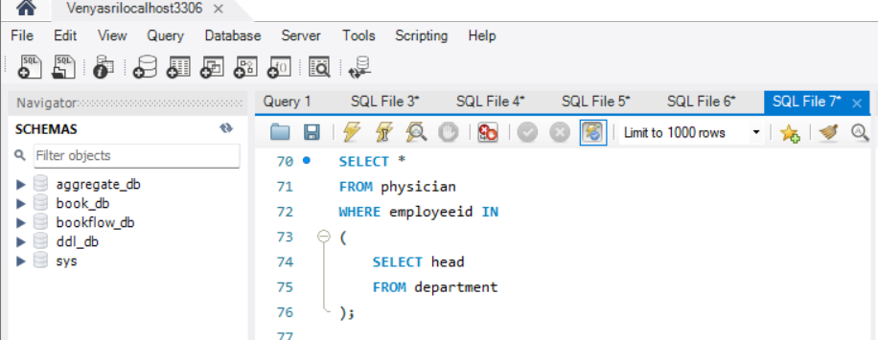
Output:
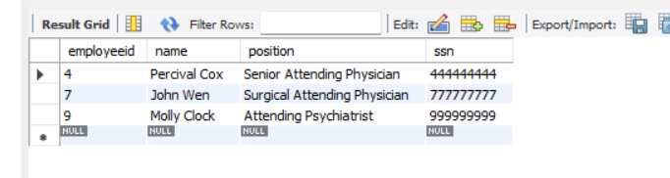

Query 16: SUBQUERY
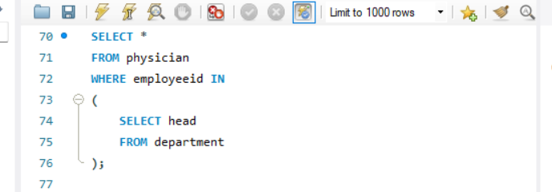
Output:

Query 17: GROUP BY + ORDER BY
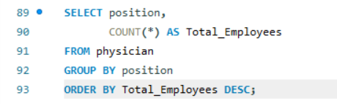

Output:
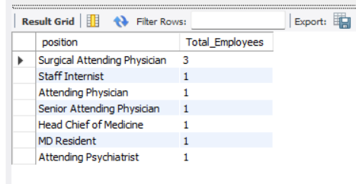

Query 18: WHERE + LIKE
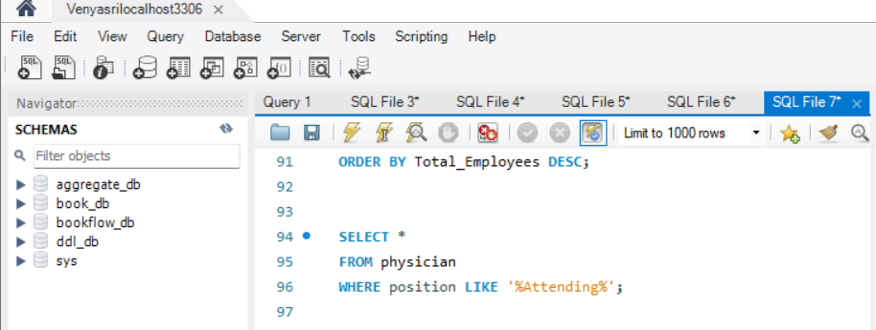
Output:
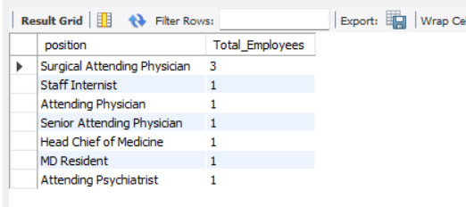

Query 19: JOIN + WHERE
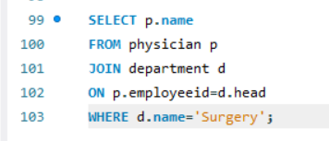
Output:
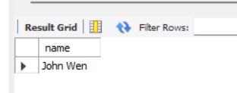

Query 20: JOIN + ORDER BY
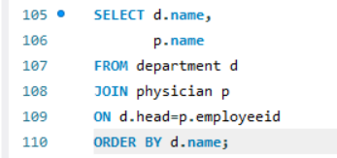
Output:
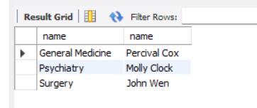

Query 21: WHERE + NOT LIKE
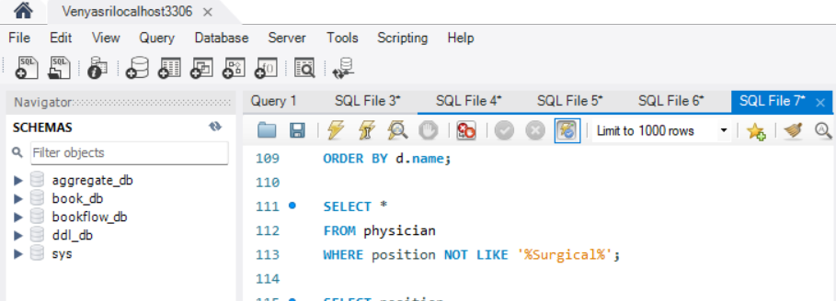
Output:
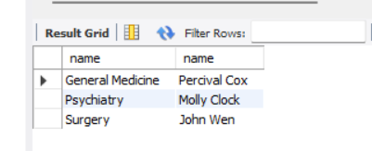

Query 22: COUNT + HAVING
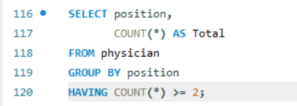
Output:
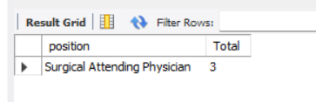

Query 23: EXISTS
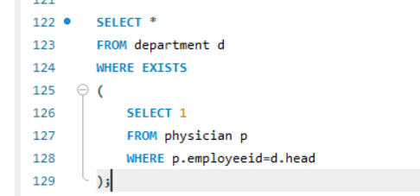
Output:
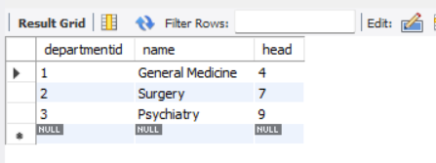

Query 24: MAX()
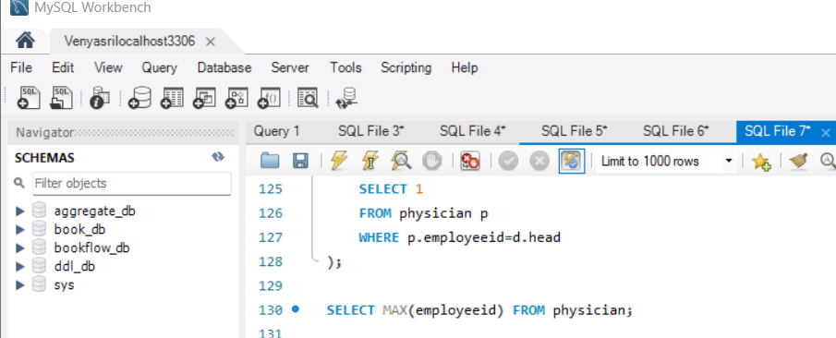
Output:
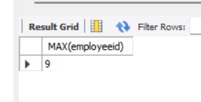

Query 25: MIN()
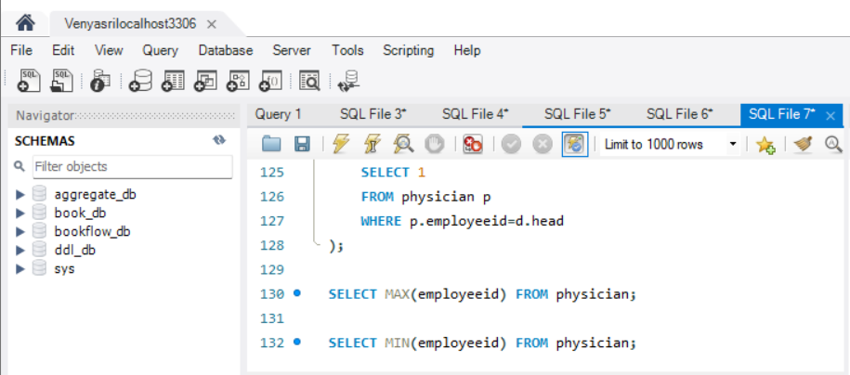
Output:
